COVID-19 VACCINE

COMMON QUESTIONS AND CONCERNS

What are the kinds of COVID-19 vaccines and how do they work?
Right now, there are three approved vaccines, from the Pfizer, Moderna, and Johnson & Johnson companies. The ones available to you depend on overall supply and the vaccination site. The Pfizer and Moderna vaccines work the same way. They contain a small piece of the virus, but not the whole thing. Getting the vaccine trains your body to recognize the virus and kill it. Both the Pfizer and Moderna vaccines require two doses.

The Johnson & Johnson vaccine is different. It uses a dead common cold virus to get a small piece of the COVID-19 virus into your body. It only requires one dose. The Johnson & Johnson vaccine doesn’t protect quite as well against mild cases of COVID-19, but it does protect as well against severe illness.

What are the side effects of the COVID-19 vaccine?
It may hurt a little where you got the shot. You may also be tired, get a fever, and have head or body aches. These side effects mean your body is getting immune. Very rarely, a person has an allergic reaction right after getting the vaccine. That is why patients must wait 15-30 minutes before leaving.

How can a safe vaccine be ready so quickly?
For three main reasons. First, because scientists have been studying coronaviruses for many years. Second, because of the severity of the pandemic, scientists all over the world worked together to find the vaccine. And third, the United States paid drug companies over $12 billion. This paid for all the steps to make the new drug.

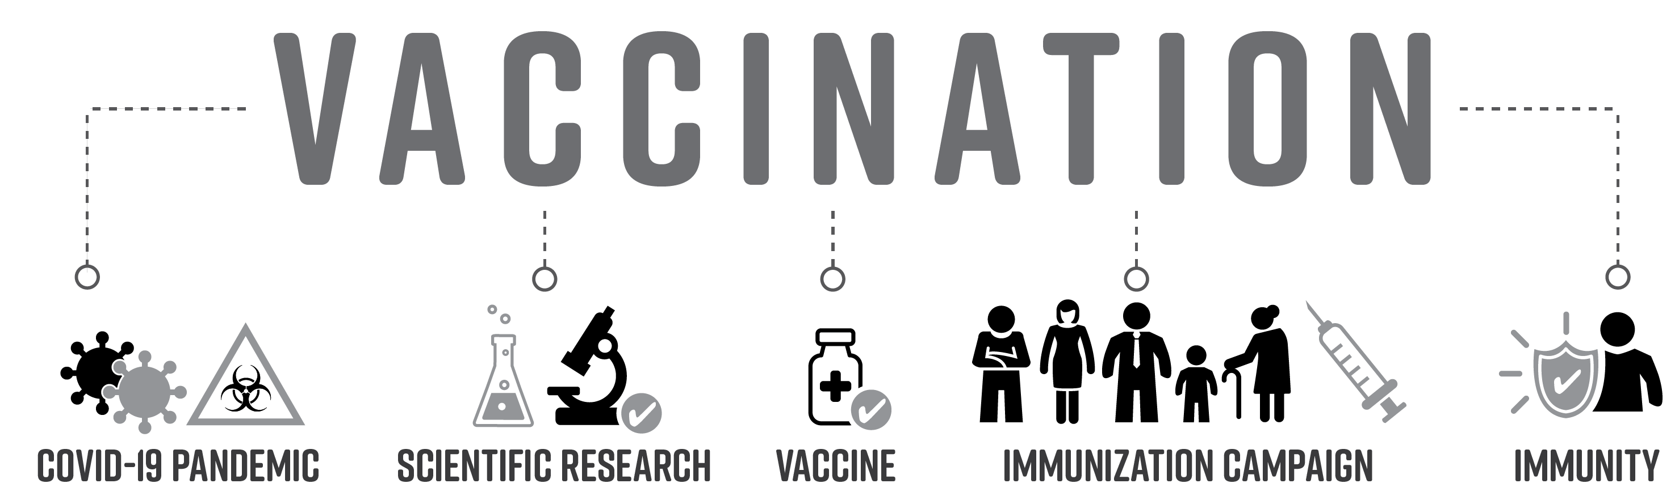
I don’t trust the government to give me health information.
There are many other good sources of information. Talk with your healthcare provider about your concerns. Ask them to give you handouts or recommend some websites. Social media is not usually a good place to get health information.

If I get the vaccine, will I be part of an experiment without my consent?
No. By law, no one can do research on you unless they tell you what they are doing and you sign a form saying you agree to be in the experiment.

Does the vaccine have something in it to track or control people?
The vaccine does not stay in your body, so there is nothing in it that can track or control you. Massachusetts does keep a record of everyone who gets a vaccine. By law, only healthcare providers and health officials can see this.

Has the vaccine been tested on people like me?
Yes. The Moderna vaccine was tested on 30,000 people. The Pfizer vaccine was tested on 37,000. The studies were evenly split between men and women. There were about 6000 people in both studies who were Black, 16,000 who were Latinx, and 3000 who were Asian. Almost half of the people in the Pfizer trial had a condition such as obesity, diabetes, or heart disease.

Can the vaccine give me or my family COVID-19?
No. None of the COVID-19 vaccines being used in the United States have whole, live viruses, so they can’t give you the disease. And because you won’t have the live virus, you can’t give it to your family.

I don’t need a vaccine. My immunity is already strong, I stay healthy with diet and exercise, or I use supplements or natural remedies.
It’s great that you are already healthy. But COVID-19 is a new virus that your body hasn’t met before. Getting the vaccine will train your body to recognize and kill the virus.

I always get sick from the flu shot, so vaccines are not good for me.
Vaccine side effects are signs that your body is getting immune.

I want to have a baby, pregnant, or nursing. Should I still get the COVID-19 vaccine?
Getting the vaccine has not made women infertile. Scientists still don’t know much about pregnancy or nursing and the vaccine. If you are pregnant or nursing, talk with your healthcare provider about what’s best for you and your baby.

Is the COVID-19 vaccine safe for people with health conditions or who take medicine?
The vaccine is safe for people with health conditions or who take medicine. It may not work as well if you have immune system or neurological problems. It also may not work as well if you take steroids or other drugs for inflammation. Talk with your healthcare provider about what is right for you.

Does the vaccine stay in my body?
No. Getting the vaccine trains your body to recognize the virus and kill it. In that process, everything from the vaccine is destroyed.

How long will immunity last?
Scientists don’t know yet. It may be a couple years. If this is the case, people may need to get the vaccine every year, as is done with influenza.

Has anyone died from the COVID-19 vaccine?
No one has died from the COVID-19 vaccine in the United States. But if you are over 80 years old, high risk, or very ill, talk with your healthcare provider about what to do.

I already had COVID-19. Do I still need the vaccine?
Yes. You can get COVID-19 a second time. If you were treated with antibodies or plasma, you should wait 90 days before getting the vaccine.

The vaccine is just another way for drug companies to make money.
The United States government already paid the drug companies over $12 billion so that everyone can get the COVID-19 vaccine for free.

Is the COVID-19 vaccine free for everyone?
No one has to pay for the COVID-19 vaccine. It’s free whether you have private insurance, Medicaid, or no insurance. To get the vaccine, you may be asked for your insurance information.

Can I get COVID-19 even after getting the vaccine?
If you were infected right before you got the vaccine, you can still get COVID-19—and give it to other people.

Does the vaccine protect against new COVID-19 variants?
It is too early to know. But just in case, drug companies are looking into creating boosters for people who already got the vaccine and changing the vaccine so that it kills the new variants, too.

What if I miss my appointment for the second dose of the vaccine?
That’s OK. Make another appointment for as soon as possible, preferably within 6 weeks of your first dose. But even if that doesn’t happen, you should still get your second shot.

