FARMOWNER SURVEY

Farm Name: _____________________________ Date Survey Completed: _____________

Address: _____________________________

City: _____________________________ State: _______ Zip: _________

Phone: __________________ Fax: __________________ Email: __________________

Farm Owner Name: __________________________________

Contact Name (if different from owner): _________________________ Phone: _______________

Season Start: ____________ Season End: ____________ Size (acreage): ____________

Crop(s): _________________________________________________________________________

Directions: _______________________________________________________________________

# of seasonal (live in Valley permanently) workers: _____

# of migrant (moved to Valley temporarily) workers: _____

Describe your farmworker population:

Race/Ethnicity: ____% Hispanic ____% Jamaican ____% Other, specify: ____________

Primary Language: ____% Spanish ____% English ____% Other, specify: ____________

Gender: ____% Male ____% Female

Have you worked with _[CRVFHP agency]______ before? [ ] Y [ ] N

If Yes, what was your experience (1-5; 1 being poor, 5 being great)? ____________

If No, would there be an interest? [ ] Y [ ] N

Have you or do you currently work with other CRVFHP Outreach Workers? [ ] Y [ ] N

What health care education/services would you support for your employees? _______________________
________________________________________________________________________________
________________________________________________________________________________

Is there a space (i.e. lunchroom) where farm workers gather where we can provide health information / supplies? [ ] Y [ ] N

Could we have access to that meeting space? [ ] Y [ ] N

On rain days (if workers are not working)? [ ] Y [ ] N

During lunch? [ ] Y [ ] N

After Hours (i.e. 5:30-6:30 PM)? [ ] Y [ ] N

Or Saturdays? [ ] Y [ ] N

Other, specify: ______________________________________________________________

Other Comments: _________________________________________________________________
________________________________________________________________________________
________________________________________________________________________________

THANK YOU!



What is the Connecticut River Valley Farmworker Health Program?

- FREE Health Care Services

Preventive and sick visits to a doctor or nurse practitioner

Pregnancy care
Dental care
Mental health counseling
Medicine prescribed by your health care provider

Eye checks and glasses
Lab work, x-rays, ultrasound

- FREE Outreach to the Farms
Health educators to talk with you about your health

Health care workers to check your blood pressure or do physical exams
Referral to community resources
Help getting other health services that are not provided at health center
Transportation to health care appointments off the farm

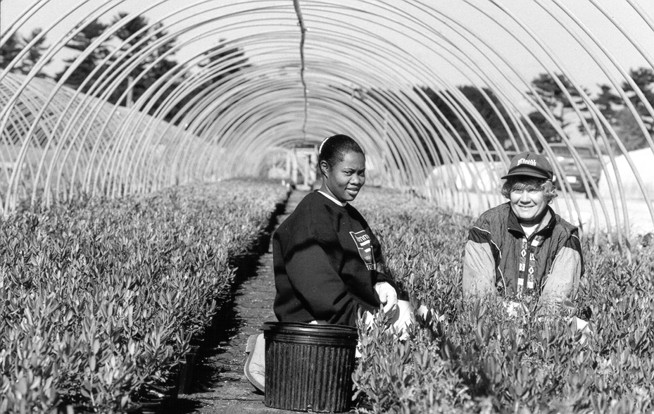
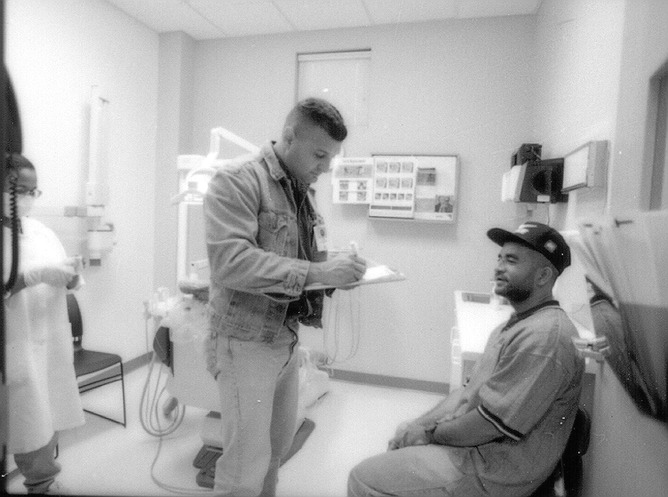

Who can receive the services?

- Migrant and seasonal farmworkers and their families
- The farmworker must work in direct farming of seasonal crops
- Farm work must be cultivating, harvesting or preparing seasonal crops for market or storage

Where can farmworkers and their families receive services?

- Health centers in Massachusetts (3) and in Connecticut (4)
- At farms Valley-wide in Massachusetts and Connecticut
- At a health care provider who participates in the Connecticut River Valley Farmworker Health Program

How can I get in contact with the health care provider?

- You can contact the health center or health care provider
- You can ask the outreach worker to help with an appointment

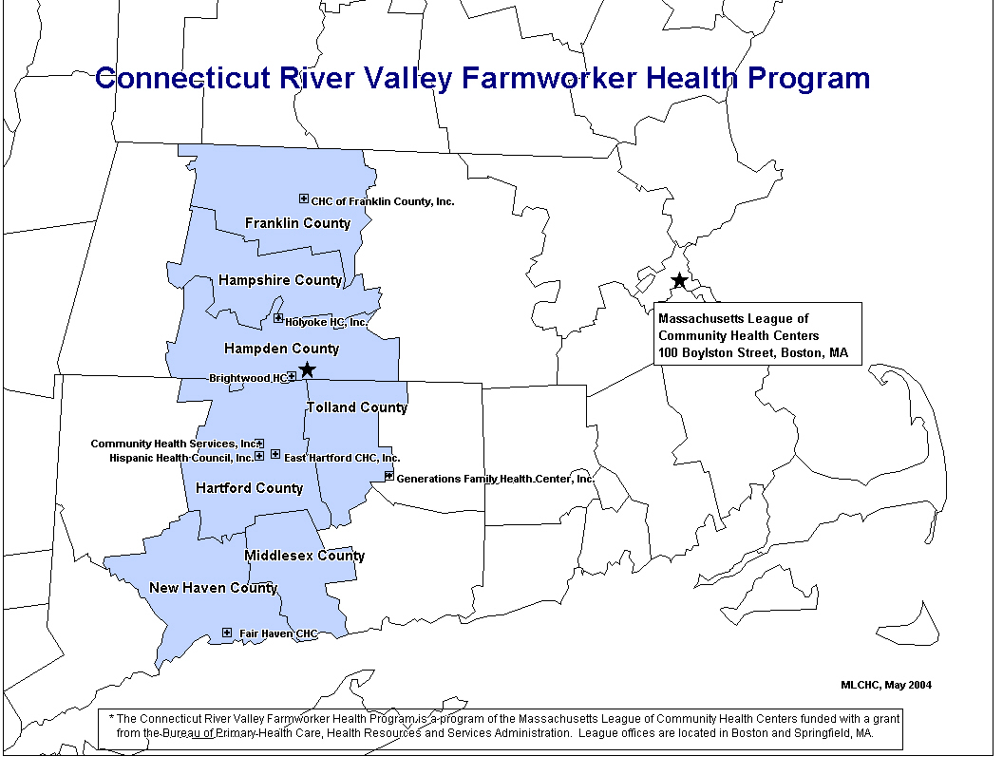

Brightwood Health Center
380 Plainfield Street
Springfield, Massachusetts 01107
Phone: 413-794-3295
Outreach worker: Luz Peña-Till
Cell: 413-426-8863

Community Health Center of Franklin County
338 Montague City Road
Turners Falls, Massachusetts 01376
Phone: 413-772-3748 x146
Outreach worker: Byron Pareja
Cell: 413-834-2174

Community Health Services, Inc. &
Hispanic Health Council
CHS: 500 Albany Avenue
Hartford, Connecticut 06120
CHS Phone: 860-249-9625
HHC: 175 Main Street
Hartford, Connecticut 06120
HHC Phone: 860-593-9157
Outreach worker: Neena Qasba
Cell: 860-597-1862
Fabrizia Harisi

East Hartford Community HealthCare
94 Connecticut Blvd
East Hartford, Connecticut 06108
Phone: 860-528-1359
Outreach worker: Rommy Torres

Fair Haven Community Health Center
374 Grand Avenue
New Haven, Connecticut 06513
Phone: 203-777-7411 x5271
Outreach worker: Denise Dean

Generations Family Health Center
1315 Main Street
Willimantic, Connecticut 06226
Phone: 860-450-7471 x241
Outreach worker: Mercedes Arroyo

Holyoke Health Center
P.O. Box 6260
230 Maple Street
Holyoke, Massachusetts 01040
Phone: 413-420-2134
Outreach worker: José Santana
Cell: 413-563-4379

Cell: 860-597-1863

CRVFHP, c/o Massachusetts League of Community Health Centers

40 Court Street, 10th Floor - Boston, Massachusetts 02108
Phone: 800-475-8455 - Fax: 617-426-0097
e-mail: massleague@massleague.org - website: www.massleague.org/CRVFHP

Esta información también está disponible en español. (1-800-475 8455 o 1-617-426-2225)

